Dockerfile - Static Web

We are going to create a static web-server.

# Step1: Create Build Repository

Create a directory called “static_web”:

| rodzers_usackis@cloudshell:~$ mkdir static_web |
| --- |

# Step2: Create the Dockerfile

Create a file called Dockerfile:

| rodzers_usackis@cloudshell:~$ mkdir static_web |
| --- |

This is the content of the Dockerfile:

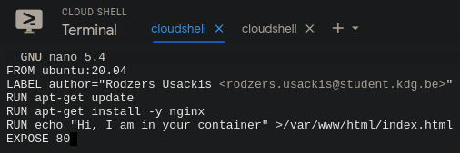

Do you understand each of the instructions? If necessary look them up.

Notes:

Didn’t know “-y“.



Didn’t know “EXPOSE”

“The EXPOSE instruction indicates the ports on which a container listens for connections.”

Read up on the RUN instructions in the docs ([Best practices for writing Dockerfiles | Docker Documentation](https://docs.docker.com/develop/develop-images/dockerfile_best-practices/#run)). Modify the above RUN instructions to comply with the best practices mentioned on the linked page. You may choose the ‘exec’ or the ‘shell’ form.

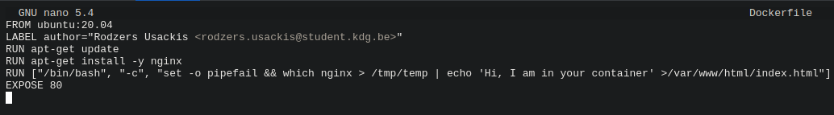

# Step 3: Build the Image

Enter the directory with the Dockerfile:

$ cd static_web

Build the image. You should know the instructions.

| rodzers_usackis@cloudshell:~/static_web$ docker build . |
| --- |

# Step 4: Run the Container

To run the container, you have to run it in detached mode (‘-d’) if you want your prompt back.

‘nginx’ is not the primary PID when the container runs. To make Docker look at nginx as primary PID, add ‘nginx -g “daemon off;”’ at the end of the run instructions, as shown below:

$ docker run -d -p 80:80 IMAGE_ID nginx -g "daemon off;“

Do you know how to change the Dockerfile so that you don’t have to add ‘nginx -g “daemon off;”’ at run time?

Tip: this involves using a CMD or ENTRYPOINT instruction in the Dockerfile

| ENTRYPOINT [“nginx”, “-g”, “daemon off;”] |
| --- |

# Step 5: Does it work?

If you’re using Docker on a GUI system, use a browser to surf to localhost to check for the message on the web page.

If you are on a CLI system:

* Try $ curl <http://localhost>
* OR: install a cli browser (lynx, links, elinks,...)

Stop all containers when you’re done.

